Scooby Doo Cartoon Notes
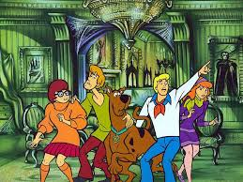

Exposition
Characters: Setting:

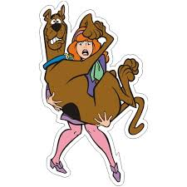

Conflict

Internal Conflict or External Conflict
Complications: These events make the plot more interesting.

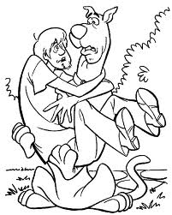

Resolution:

